**Lab 8 [IP Addressing, Subnetting and Static NAT]**

**Outline:**

1. Overview of IPv4 Addressing and Subnetting
2. Create subnets in LANs
3. Configure static NAT

**Tasks:**

1. Create the network as shown in the following figure with 2 routers R1 and R2. Connect 4 switches S1, S2, S3 and S4 for four subnets.

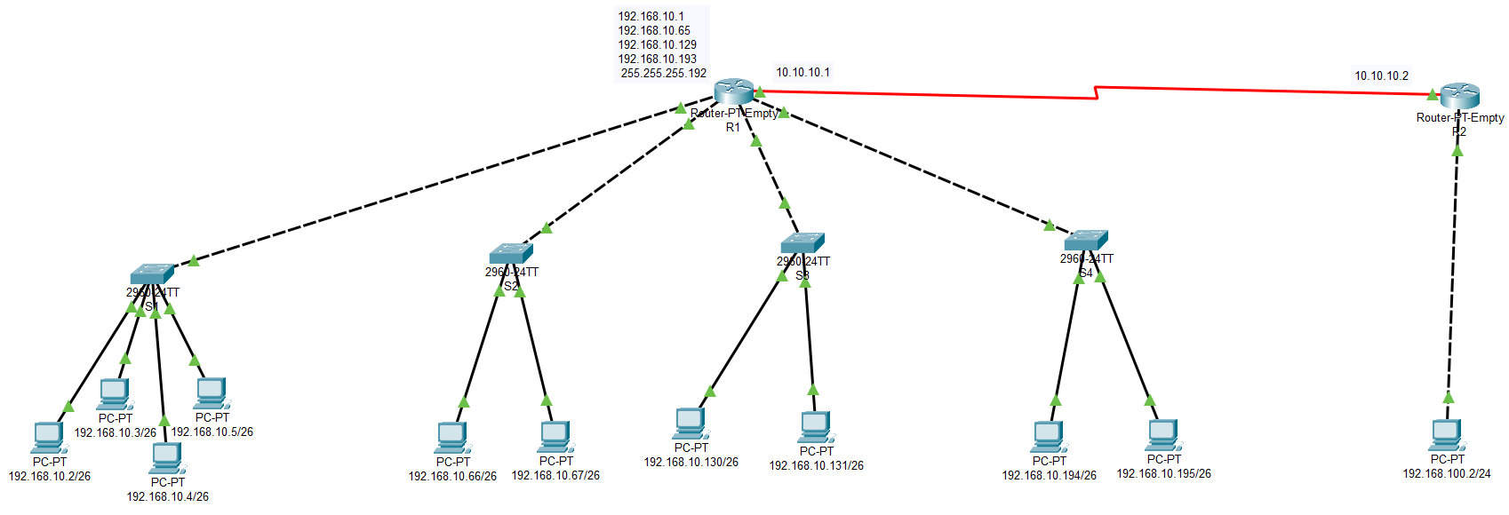

**IP Address Allocation and Subnetting:**

* Use the IP range 192.168.10.0/24 and:
  + Divide the network into four subnets (e.g., using a /26 subnet mask for 64 addresses per subnet).
  + Allocate IP addresses to each PC within each subnet.

**Subnet Allocation Example:**

* **Subnet 1:** 192.168.10.0/26 (Range: 192.168.10.1 - 192.168.10.62)
* **Subnet 2:** 192.168.10.64/26 (Range: 192.168.10.65 - 192.168.10.126)
* **Subnet 3:** 192.168.10.128/26 (Range: 192.168.10.129 - 192.168.10.190)
* **Subnet 4:** 192.168.10.192/26 (Range: 192.168.10.193 - 192.168.10.254)

**Static Route between 2 routers:**

* **Serial Connection between R1 and R2:**
* **IP address at R1:** 10.10.10.1 255.0.0.0
* **IP address at R2:** 10.10.10.2 255.0.0.0
* **Create a static route between R1 and R2 traffic for each subnet.**

**Verification and Connectivity Testing:**

* Use the ping command to check connectivity:
  + PCs within the same subnet should communicate successfully.
  + PCs from different subnets should communicate through the router.

**Static NAT (Network Address Translation)**

**Configure Static NAT on Router 1**

* Step 1: Access Router A configuration mode.
* Step 2: Define inside and outside interfaces.
  + Set the LAN interface(s) as inside.
  + Set the WAN interface as outside.

**interface [Interface]**

**ip nat outside/inside**

* Step 3: Map each IP address in LANs on R1 to a corresponding virtual IP in the 20.20.20.0/24 range for communication over the WAN.

For example, let’s say you have a device in LAN with IP 192.168.10.2 that you want to map to 20.20.20.2 on the WAN.

**ip nat inside source static 192.168.10.5 10.10.1.5**

Repeat this command for each device that needs a unique virtual IP for WAN communication.

**Configure Static NAT on Router 2**

Same steps as done for R1

**Configure Static Routes on Each Router**

On Router 1, add a static route to reach LAN’s virtual IP range via Router 2 WAN IP.

On Router 2, add a static route to reach LAN’s virtual IP range via Router 1 WAN IP.